User Guide

# Home Page

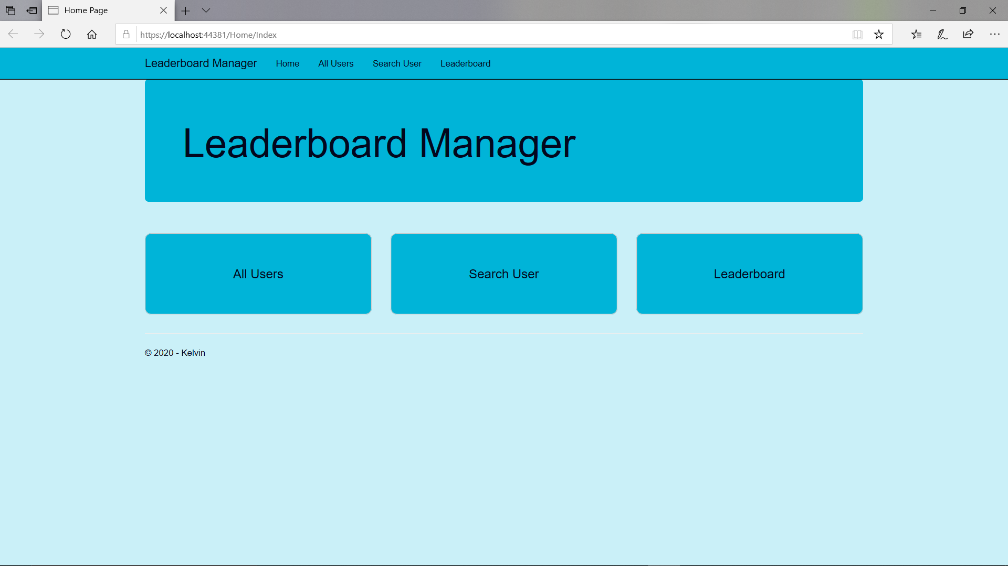

Running the project will display the home page above. The three options are to display all users, search for a specific user by user id or to display the leader board. The options can be selected either by the three buttons or from the navigation bar.

# Get Users

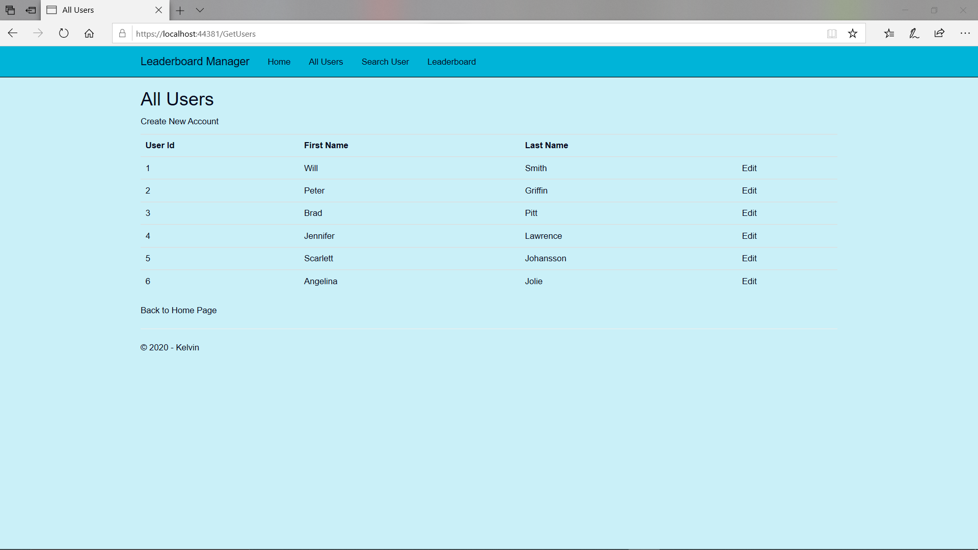

Clicking the All Users button will display the above. This page will retrieve all the users from the database. From here, excluding navigation, you can either create a new user, edit an existing user or return to home page.

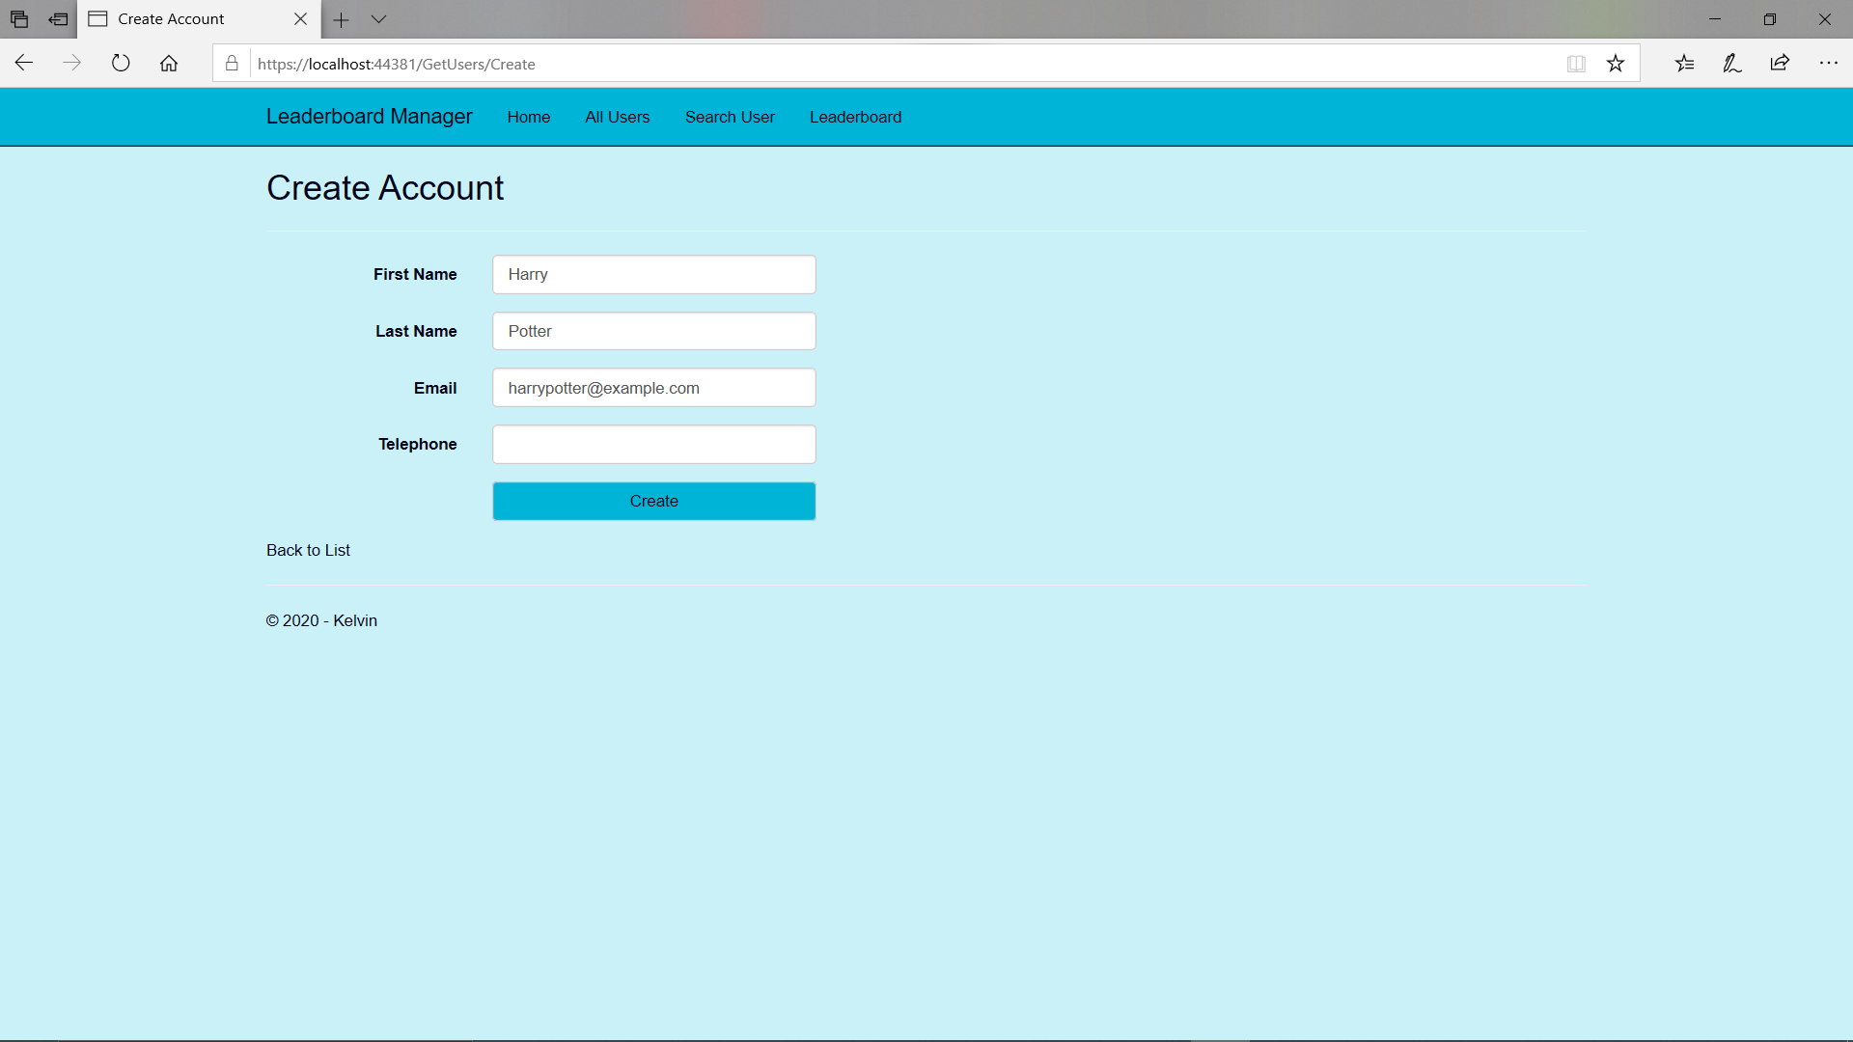

Clicking on the Create New Account link will allow for you to enter the details of a new user. Pressing the Create button will create a new user to the database and take you back to the previous page.

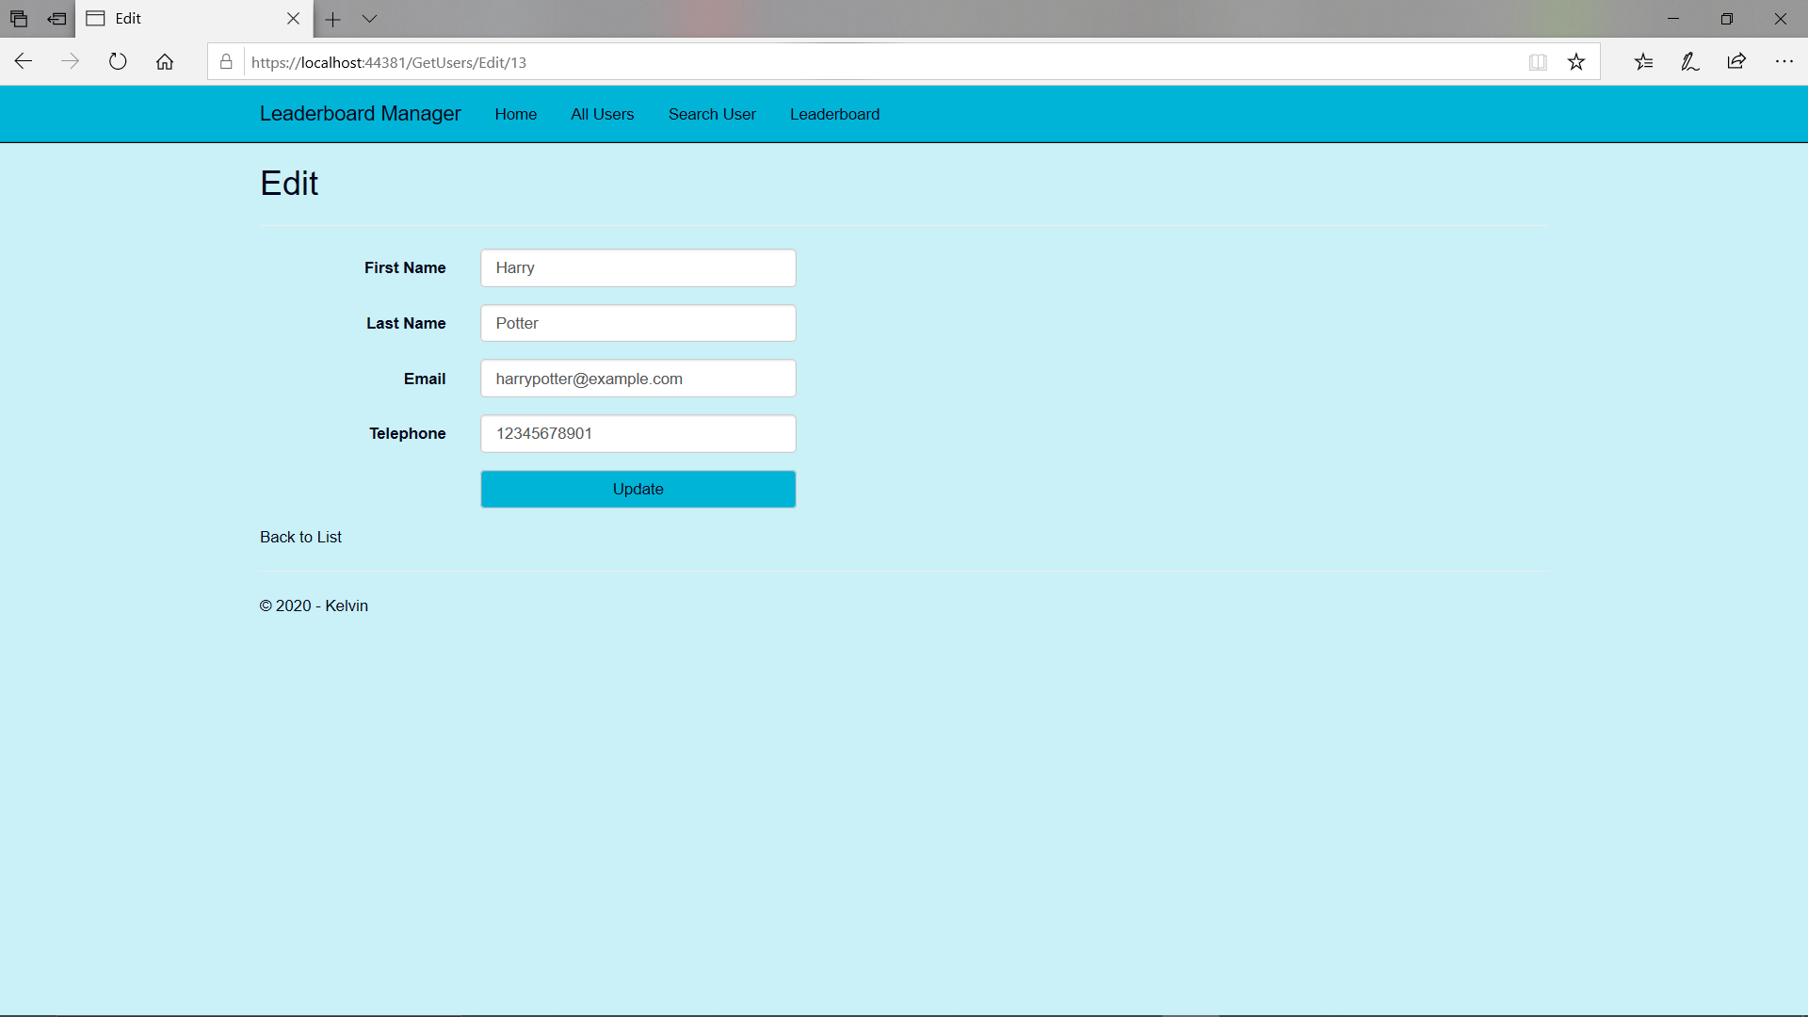

Selecting Edit from the All Users page will allow for you to update the desired user via the update button.

# Search User

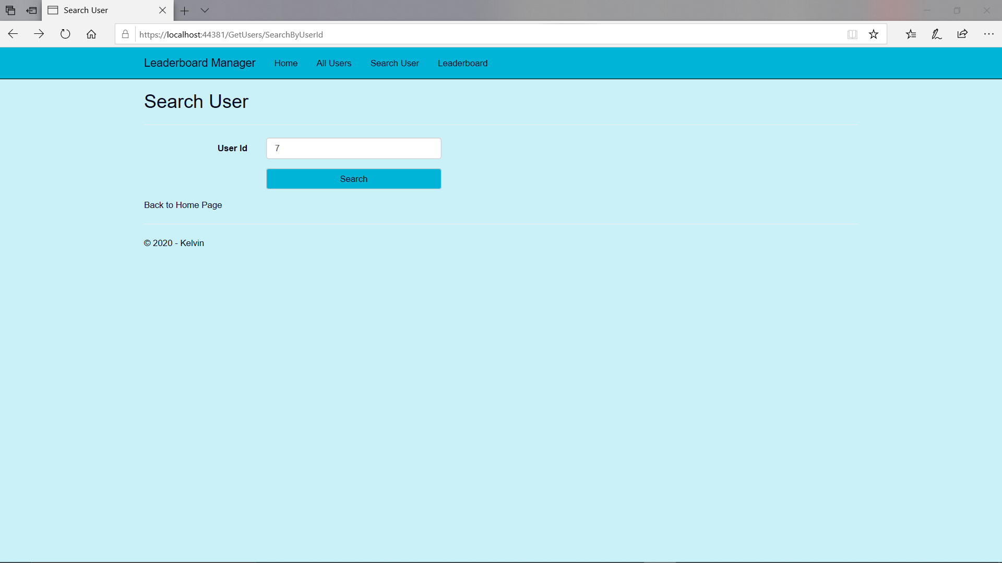

From the Home Page, selecting the Search User option will allow for you to input a user id to search from. The search button will display a single record based on the input.

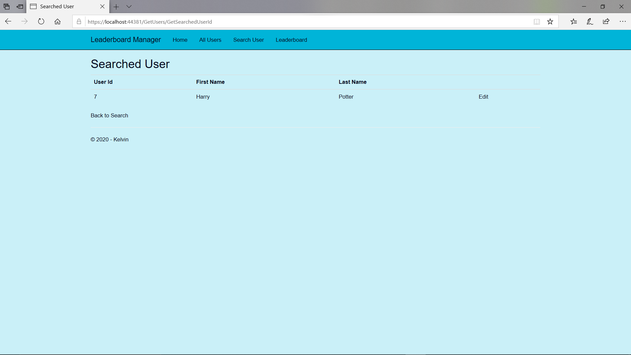

This page also allows for the user record to be updated via the Edit link, as shown previously.

# Get Leaderboard

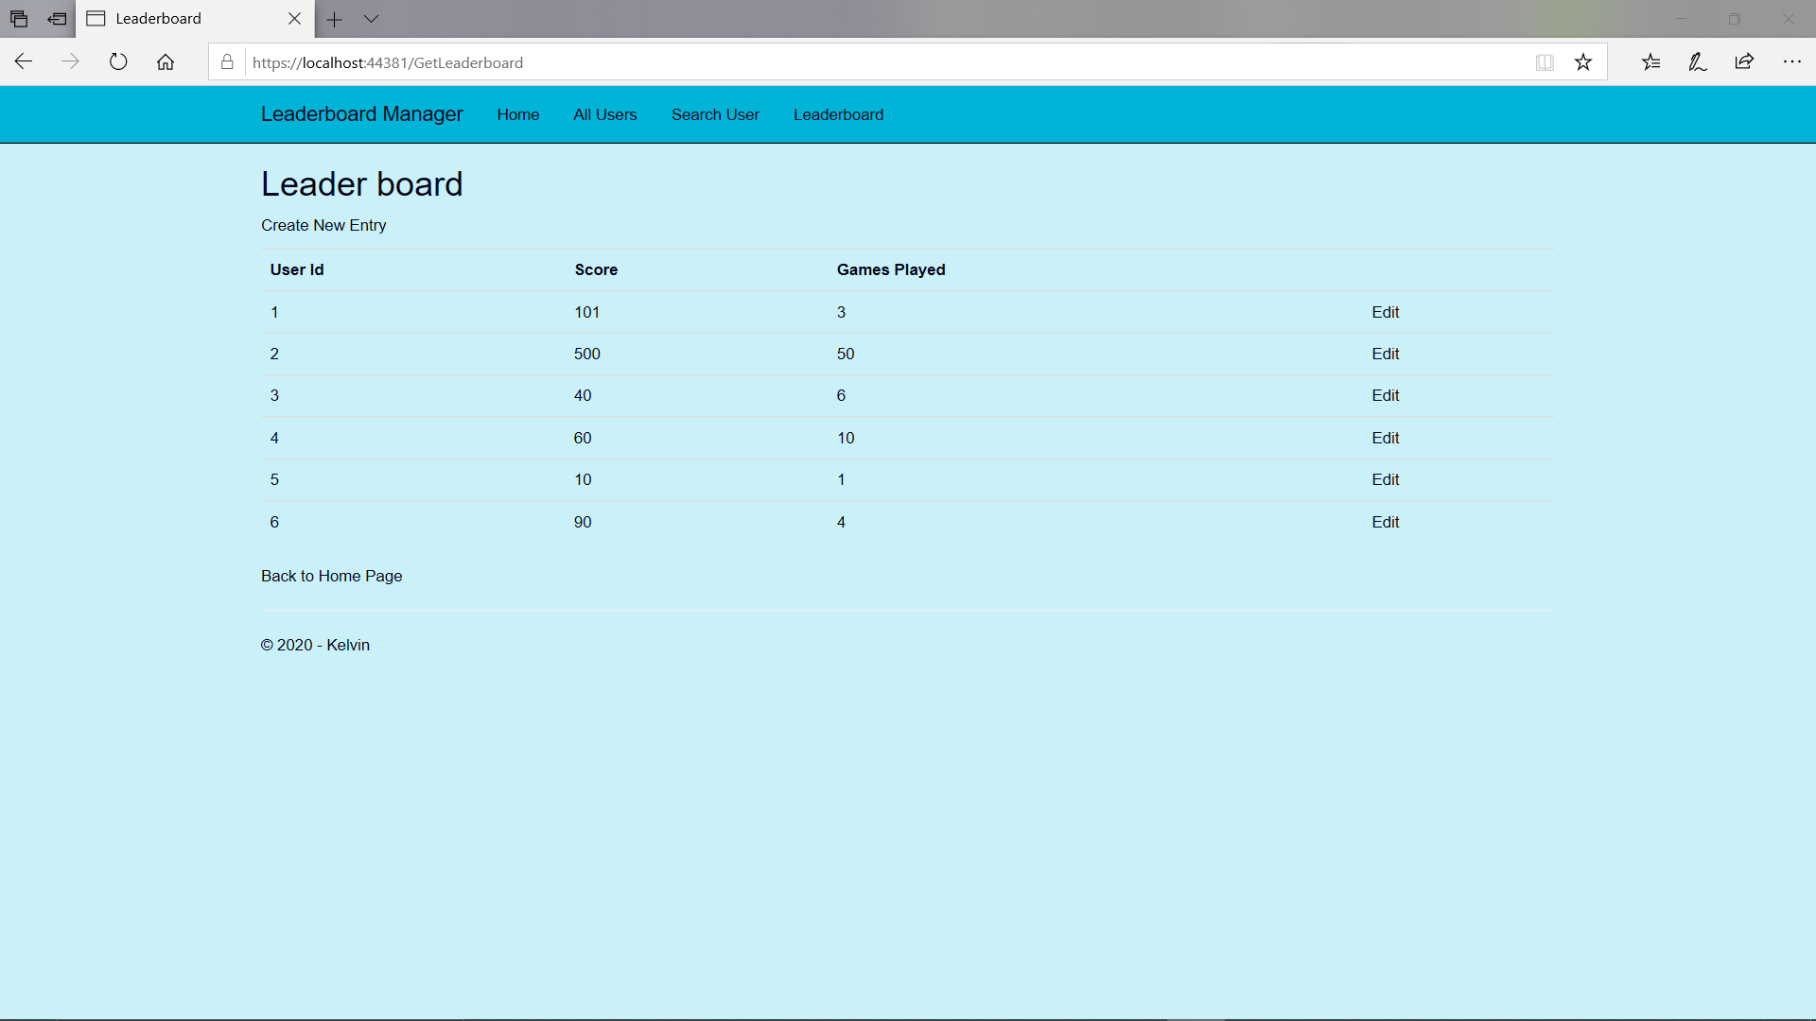

Selecting the Leaderboard option from the Home Page or navigation will display the leader board list. This page enables for you to create a new entry or edit an existing entry.

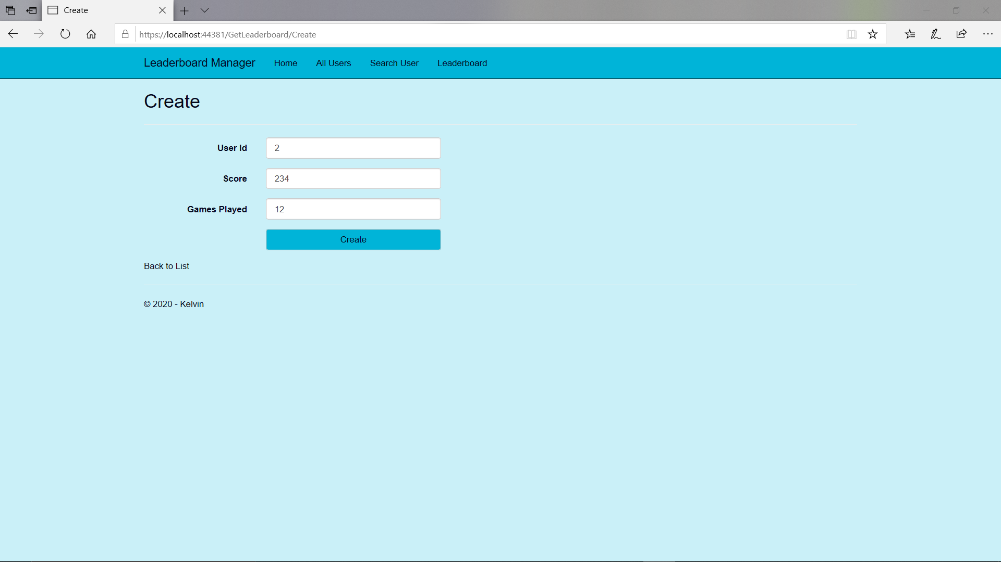

Clicking on the Create New Entry will allow for you to input the new entry details, pressing the Create button will create the record in the database.

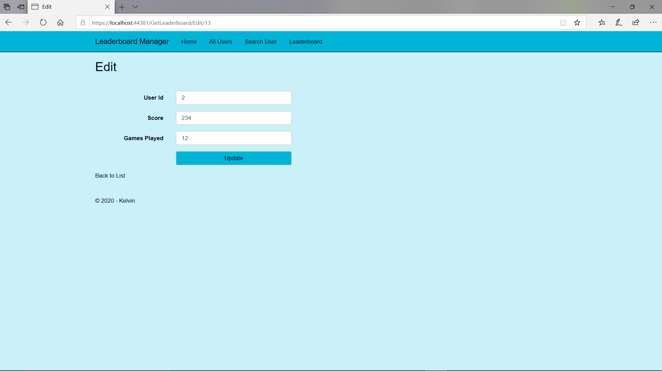

The Edit link from the Leaderboard page will allow for the entry to be changed via the update button.